

Certification of Project Deliverable

NAME OF DELIVERABLE | COMP255 – Assignment 1 – Part 2
DATE SUBMITTED | 04 / 10 / 2013
PROJECT GROUP NUMBER | Group 7

We, the undersigned members of the above Project Group, collectively and individually certify that the above Project Deliverable, as submitted, is entirely our own work, other than where explicitly indicated in the deliverable documentation.

SURNAME | GIVEN NAME | STUDENT NUMBER | SIGNATURE
CREASEY | BROGAN | 43348637 | 
HANCOCK | RONALD | 42738083 | 
HEIMLICH | SARAH | 42880777 | 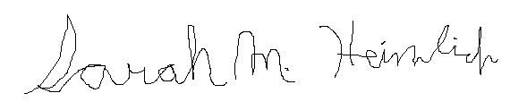
KETTLE | CHRISTOPHER | 42913349 | 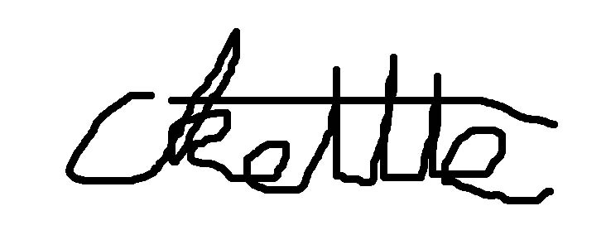
MOSS | JAMES | 43295630 | 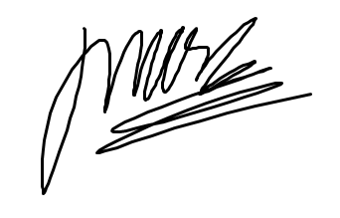
NB: Please print “SURNAME” and “GIVEN NAME”
© Macquarie University, 2007
List of Tasks
Name of task | Performed by | Checked by
Task 1.1 – Introduction | Sarah / Christopher | Ronald
Task 1.2 – Overall Description | James | Ronald / Sarah
Task 1.3 – Requirements | Brogan | Ronald / Sarah / James
Task 2 – Develop User Stories | Ronald | Sarah / Christopher
Task 3 – Use Case Diagram | Ronald | TEAM
Task 4 – Use Case Descriptions | Ronald | Sarah
Task 5 – Analysis Class Diagram | James | Sarah / Ronald
Task 6 – Sequence Diagrams | Sarah / James | Ronald
Task 7 – Requirements Traceability Matrix | Brogan | Ronald
Task 8 – Acceptance Testing | Ronald | Sarah
Task 9 – User Interface Evaluation | Christopher / Brogan | Sarah / James / Ronald
Task 10 – System Design | James / Sarah | Ronald
Task 11 – Design Level Class Diagram | James | Sarah
Task 12 – One Design Level Sequence Diagram | James | Ronald
Task 13 – State Diagram | Sarah | Ronald
Task 14 – Complex Algorithm Specification | Brogan / Sarah | Ronald
Task 15 – Quality | Christopher | Sarah / Ronald
Task 16 – Project Management | Christopher / Brogan | Sarah / Ronald / James
Task 17 – List of Assumptions | Sarah | Ronald
Assembly of Submission | Sarah | TEAM
Printing | Christopher
Binding | James

